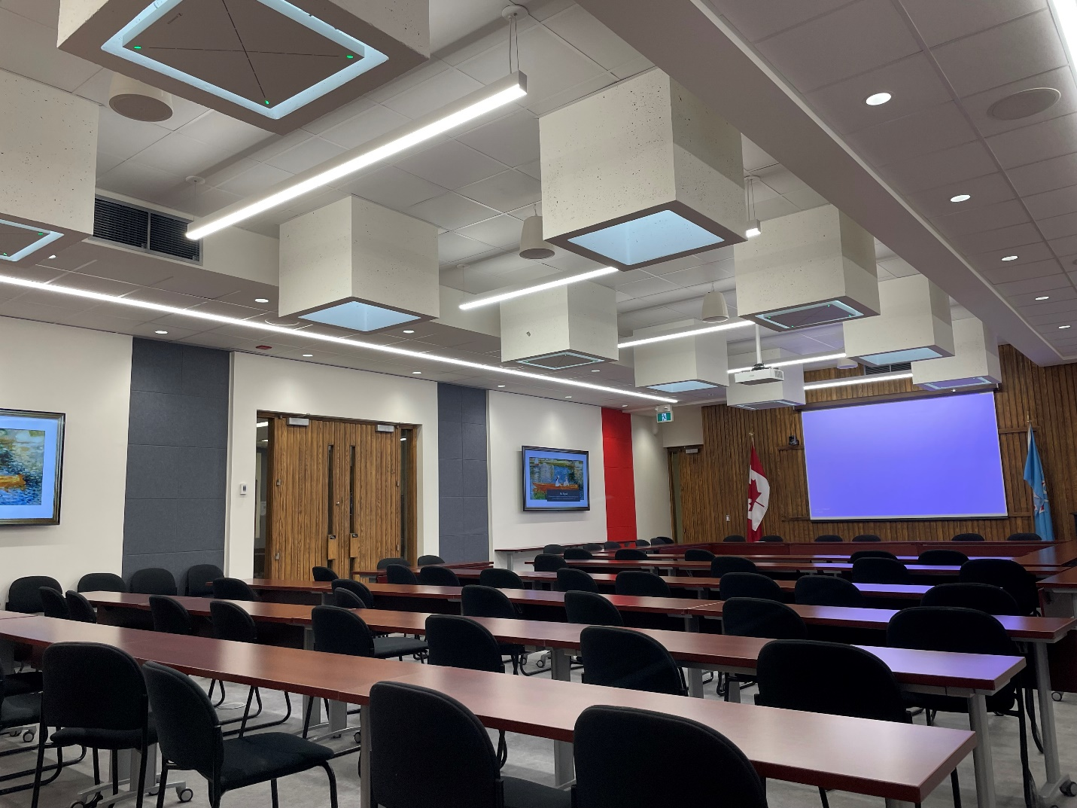
Carleton University Refreshes its Hybrid Learning Strategy with Sennheiser TeamConnect Ceiling 2
The university deployed 43 TeamConnect Ceiling 2 microphones across campus to facilitate hybrid learning and state-of-the-art collaboration, including in the historic Senate Room
Ottawa, February 22, 2024 – Carleton University in Ottawa, Canada, underwent a total renovation to revamp its antiquated Senate Room into a modern meeting space equipped with cutting-edge AV technology, featuring superior audio solutions from Sennheiser. The university selected Sennheiser's TeamConnect Ceiling 2 (TCC 2) microphones to create a seamless environment for Senate meetings and conferences. The ceiling microphones’ ease of deployment and ability to capture high-quality audio from anywhere in the room prompted further deployment of 37 TCC 2s across the university to facilitate hybrid learning.
Until recently, the 150-acre campus at Carleton University was home to a severely outdated Senate Room, a longtime gathering space for the school's senior academic body, comprised of faculty, students, alumni, and senior administration. With the 49 x 33 ½ ft room largely untouched since the late 60s, the university stakeholders recognized the need to refresh the room both aesthetically and functionally. An architect was brought in to retrofit the rough, exposed concrete and dark ceilings with a modern look. Armand Doucet, AV specialist at the university, was consulted to add state-of-the-art AV technology to the space.
The Senate Room had been through several technology iterations, with the ultimate goal to create a room that could adequately host 60-80 people during audio conferences. Armand needed a multifunctional space where the school Senate could meet and efficiently carry out their governing responsibilities and where students and faculty could reserve a dedicated space throughout the year for various small conferences.
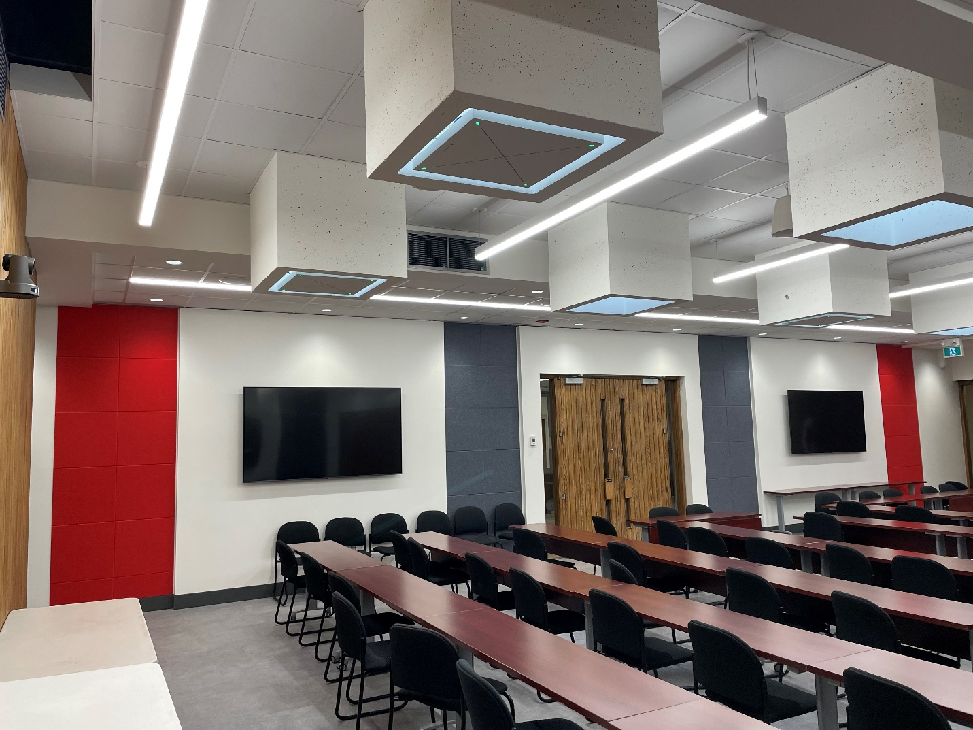
The recently renovated Senate Room at Carleton University features six Sennheiser TeamConnect Ceiling 2 microphones throughout.
Armand said, “The guiding principle for the remodel was to have the least invasive technology possible that would pick up conversations anywhere in the room. It needed to consistently produce high-quality audio, without needing an AV technician on hand.”
After testing several vendors, Armand decided Sennheiser's TCC 2 microphone was the ideal solution to refresh the Senate Room. TCC 2’s patented dynamic beamforming technology picks up all audio in a room and uses digital signal processing to automatically locate and highlight the individual speaking, regardless of where they sit, stand or move.
The choice came down to several factors, with adaptability and ease of use key, because of the university’s small internal staff. Armand adds, “One of the best parts was that the TCC 2s were so easy to deploy. After installing the tile, we simply needed the two connectors. Then we could open Control Cockpit, and within the hour, we had a functional tool that was easily handling all of the room’s noise.” With limited it was also essential that Sennheiser’s Technical Application Engineers were available at every step of the process. from initial design concepts through installation.
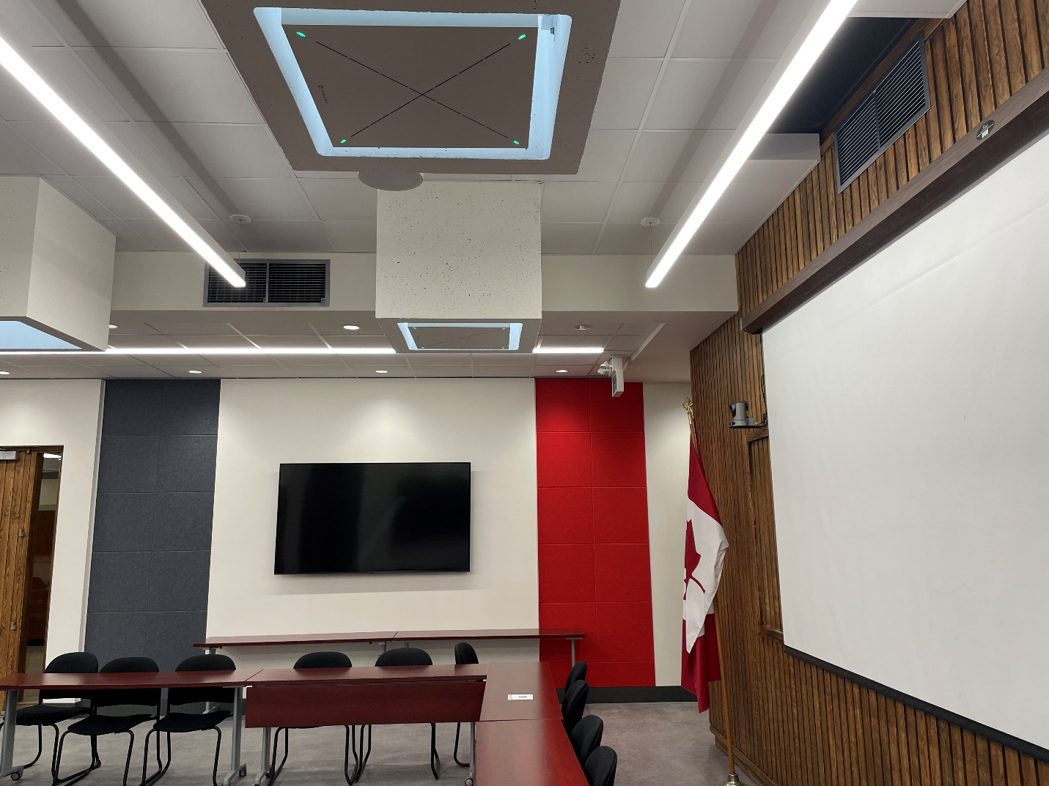
The university selected Sennheiser's TeamConnect Ceiling 2 (TCC 2) microphones to create a seamless environment for Senate meetings and conferences.
Within a week, Armand and his team installed six TCC 2s into the Senate Room’s newly designed skylights, which created a beautiful and functional space. With the TCC 2s flexible analog and digital inputs and outputs, Armand could use the microphones in collaboration with the room’s new QSC digital signal processor (DSP).
Since the rollout of the TCC 2s in the Senate Room, Armand has received positive feedback from Senate members and conference participants. Armand says, “I’ve heard nothing but good reviews about the space since the renovation. The TCC 2s easily cover the whole room. When the Senate meets, and there are people in the back who ask questions, they’re heard. When people are in the front, they’re heard. When they are lecturing to the space, TruVoiceLift ensures they’re being heard. The TCC 2s have finally made the space functional and blend in beautifully with the remodel.”
Following the successful Senate Room installation, Armand deployed dozens of additional TCC 2s across campus to support labs and seminar rooms. These deployments came at a crucial time as the university needed to quickly adapt to support hybrid learning. With a single TCC 2 able to cover a room fit for 20-100 people, there were 43 microphones installed across five buildings to accommodate flexible seating designs and discussion sessions.
In the future, Armand plans to continue to grow Carleton University’s setup with Sennheiser. He is eager to utilize the TeamConnect Ceiling Medium (TCC M) and address the unique challenges of properly outfitting lecture halls that seat hundreds of students at a time.
About Sennheiser
We live and breathe audio. We are driven by the passion to create audio solutions that make a difference. Building the future of audio and bringing remarkable sound experiences to our customers – this is what the Sennheiser brand has stood for since more than 75 years. While professional audio solutions such as microphones, conference systems, streaming technologies and monitoring systems are part of the business of Sennheiser electronic GmbH & Co. KG, the business with consumer devices such as headphones, soundbars and speech-enhanced hearables is operated by Sonova Holding AG under the license of Sennheiser.
www.sennheiser.com
www.sennheiser-hearing.com
Local Press Contact
Daniella Kohan
daniella.kohan@sennheiser.com
+1 (860) 222-4226

Global Press Contact
Jeff Horan
jeffrey.horan@sennheiser.com
+1 860-598-7539

